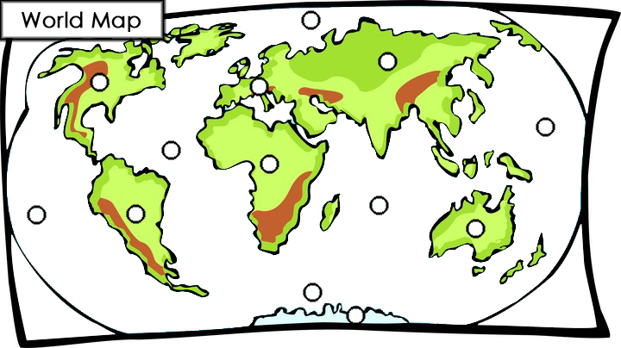
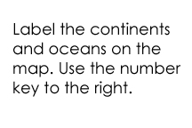 | Continents  - Africa  - Antarctica  - Asia  - Australia  - Europe  - North America  - South America | Oceans  - Arctic Ocean  - Atlantic Ocean  - Indian Ocean  - Pacific Ocean  - Southern Ocean
© 2005 www.bogglesworldesl.com

