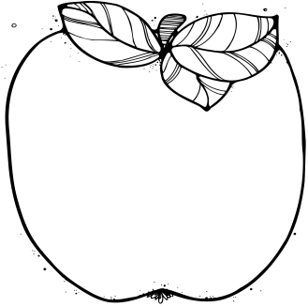M

**Norris Resource Schedule**

Monday: Computer Lab

Tuesday: Art/Music

Wednesday: P.E.

Thursday: Rotation

Friday: Library

**Contact Information:**

Bodlak: [cbodlak@amherst.k12.va.us](mailto:cbodlak@amherst.k12.va.us);

Cassise: [acassise@amherst.k12.va.us](mailto:acassise@amherst.k12.va.us);

**August 31: PTO T-Shirt Order**

**September 5: Labor Day Holiday, No School**

**September 15: Interims and PTO Back to School Bash at 5:30**

**October 27: Tentative Field Trip Date to Luray Caverns. (We are in the process of planning this and the date could change. Stay tuned…)**

August 29-Sept. 2

Lunch 11:35-12:05

**Notes from the Teachers:**  
  
*Mrs. Bodlak will be PALs testing 3 days this week. She will be working with each student to determine their reading levels.

*Mrs. Cassise will be welcoming a student teacher on Wednesday. Her name is Ms. Goldsborough. We look forward to her learning and teaching in our classroom.

**What We’re Learning:**  
  
**Reading:** Context clues and Inferring (SOL 5.4, 5.5)

**Writing/ Grammar:** Paragraphs (SOL 5.8)

**Word Study:** Homophones (SOL 5.4)

**Math**: Single and Multi-Step Word Problems with emphasis on division.

(SOL 5.4)

**History:** U.S. Regions and waterways (USI.2b,c)

**Science:** Weathering, Erosion, and Deposition, Types of Rocks and Rock Cycle

(SOL 5.7f,g,a,b)

# Important Dates:

Fifth Grade   
 News