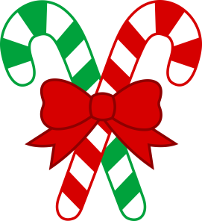M uC

**December 5**

* PTO Santa’s Gift Shop

**December 6**

* PTO Cookies with Santa 6-8

**December 7**

* Science Benchmark

**December 9**

* Reading Benchmark

**December 12**

* English Benchmark

**December 13**

* Math Benchmark
* Chorus Musical 6

**December 15**

* History Benchmark

**December 19-January 2**

* Christmas Holiday

**January 3**

* School Reopens
* Amelon Subway Night

**Contact Information:**

Cassise: [acassise@amherst.k12.va.us](mailto:acassise@amherst.k12.va.us);

Bodlak: [cbodlak@amherst.k12.va.us](mailto:cbodlak@amherst.k12.va.us)

# Important Dates:

Dec. 5-9

Lunch 11:35-12:05

**Notes from the Teachers:**

*Continue returning corrected work for improved grades.

*Students are working toward another incentive before winter break. We look forward to celebrating their positive behavior.

**What We’re Learning:**  
  
**Reading:** Historical Fiction cause and effect. (SOL 5.5)

**RAP:** We are reading aloud the book Maniac Magee by Jerry Spinelli. Ask your child about it.

**Writing/ Grammar:** Plural Possessives and Writing Brochures

(SOL 5.7, 5.8)

**Word Study:** Word study groups based on individual needs and word of the day (SOL 5.4)

**Math**: Reviewing computation, algebraic expressions, distributive property, order of operations, patterns, word problems, prime, and composite for benchmark testing.

(SOLs 5.1, 5.2, 5.3, 5.4, 5.6, 5.7, 5.17, 5.18, 5.19)

**History:** Revolutionary War (USI.6)

**Science:** Reviewing scientific method, matter, oceans, and Earth for benchmark testing.

(SOLs 5.1, 5.4, 5.6, 5.7)

Fifth Grade   
 News