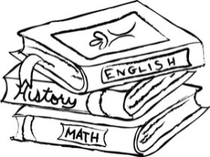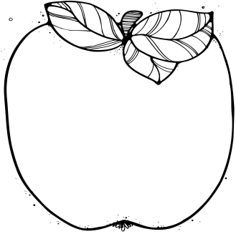M

**Cassise Resource Schedule**

Monday: Computer Lab

Tuesday: Art/Music

Wednesday: P.E.

Thursday: Rotation

Friday: Library

**September 20:** Parent/Teacher Conferences 4-6.

**September 23:**

* Green Field Trip Forms Due
* College T-Shirt Day

**September 26-30:** Amelon Book Fair

**September 26-October 21**

Money Collected for Field Trip $45

**October 3:** Yearbook Baby Pictures Due Date

**October 11:**

Yearbook Pictures

**Contact Information:**

Bodlak: [cbodlak@amherst.k12.va.us](mailto:cbodlak@amherst.k12.va.us);

Cassise: [acassise@amherst.k12.va.us](mailto:acassise@amherst.k12.va.us);

**Notes from the Teachers:**

* Students are able to correct graded papers to earn extra points on assignments. Please take advantage of this opportunity.

**What We’re Learning:**  
  
**Reading:** Reading fantasy novels focusing on inferring. (SOL 5.4, 5.5)

**RAP:** We are reading aloud the book Crash by Jerry Spinelli. Ask your child about it.

**Writing/ Grammar:** Writing paragraphs, sentences, and fragments.

(SOL 5.8)

**Word Study:** Word study groups based on individual needs and word of the day (SOL 5.4)

**Math**: Variable Expressions (SOL 5.18)

**History:** Native Americans **Test this week.** (USI.3)

**Science:** **Earth Test Tuesday** (SOL 5.7)

Scientific Method (SOL 5.1)

September 19-23

Lunch 11:35-12:05

# Important Dates:

Fifth Grade   
 News