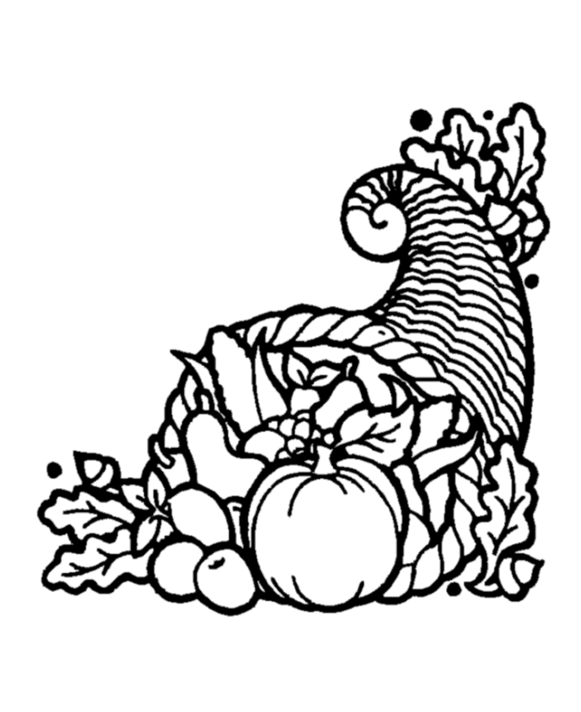**e**M

**Contact Information:**

Bodlak: [cbodlak@amherst.k12.va.us](mailto:cbodlak@amherst.k12.va.us);

Cassise: [acassise@amherst.k12.va.us](mailto:acassise@amherst.k12.va.us);

**November 3**

* Amelon’s Math 24 Competition at 9:15

**November 8**

* Teacher Workday, no school

**November 10**

* Lifetouch Class Picture (Make-up Picture Day)

**November 11**

* Veteran’s Day (wear red, white, and blue)

**November 15**

* ACPS Math 24 Competition, 5:30 at MMS

**November 17**

* **Technology Night, 6-7**

**November 18**

* **Interims**

**Notes from the Teachers:**

*Continue returning corrected work for improved grades.

*We have begun a new incentive program from now until Thanksgiving Break. Students are able to earn a hole punch on a ticket each day. If they have 20 punches before the incentive party, they will be invited to attend. We look forward to celebrating positive behaviors.

**What We’re Learning:**  
  
**Reading:** Main idea with nonfiction. (SOL 5.6)

**RAP:** We are reading aloud the book Maniac Magee by Jerry Spinelli. Ask your child about it.

**Writing/ Grammar:** Using various resources to do research. (SOL 5.9)

**Word Study:** Word study groups based on individual needs and word of the day (SOL 5.4)

**Math**: Converting fractions to decimals and vise versa. Comparing and ordering fractions and decimals. (SOL 5.2)

**History:** Colonial Regions (USI.5)

**Science:** Oceans (SOL 5.6)

Oct. 30 – Nov. 4

Lunch 11:35-12:05

# Important Dates:

Fifth Grade   
 News