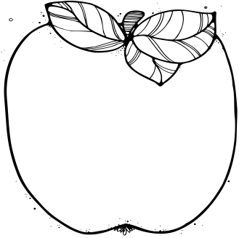M

**September 26-30:** Amelon Book Fair

**September 26-October 21**

Money Collected for Field Trip $45

**October 3:** Yearbook Baby Pictures Due Date

**October 11:**

Yearbook Pictures

**October 14:**

Nine Weeks Ends

**October 17:**

Teacher Work Day, No School for Students

**October 27, 7:00-5:30:**

Field Trip to Luray Caverns

**Bodlak Resource Schedule**

Monday: Computer lab

Tuesday: Art

Wednesday: PE

Thursday: Art

Friday: Library

**Contact Information:**

Bodlak: [cbodlak@amherst.k12.va.us](mailto:cbodlak@amherst.k12.va.us);

Cassise: [acassise@amherst.k12.va.us](mailto:acassise@amherst.k12.va.us);

**Notes from the Teachers:**

* If you plan to chaperone our field trip to Luray Caverns remember you must be fingerprinted and approved before our trip.

*Students are able to correct graded papers to earn extra points on assignments. Please take advantage of this opportunity.

**What We’re Learning:**  
  
**Reading:** Reading fantasy novels focusing on Context Clues and Text Features (SOL 5.4, 5.5)

**RAP:** We are reading aloud the book Crash by Jerry Spinelli. Ask your child about it.

**Writing/ Grammar:** Writing paragraphs, sentences, and fragments.

(SOL 5.8)

**Word Study:** Word study groups based on individual needs and word of the day (SOL 5.4)

**Math**: Distributive Property (SOL 5.19)

**History:** European Explorers (USI.4)

**Science:** Scientific Method (SOL 5.1)

September 26-30

Lunch 11:35-12:05

# Important Dates:

Fifth Grade   
 News